Q2)

A)

3NF screenshot :

B) Tables created in SQL screenshots :

Employees Table Screenshot :

Jobs table screenshot :

Roles Table Screenshot:

2-C

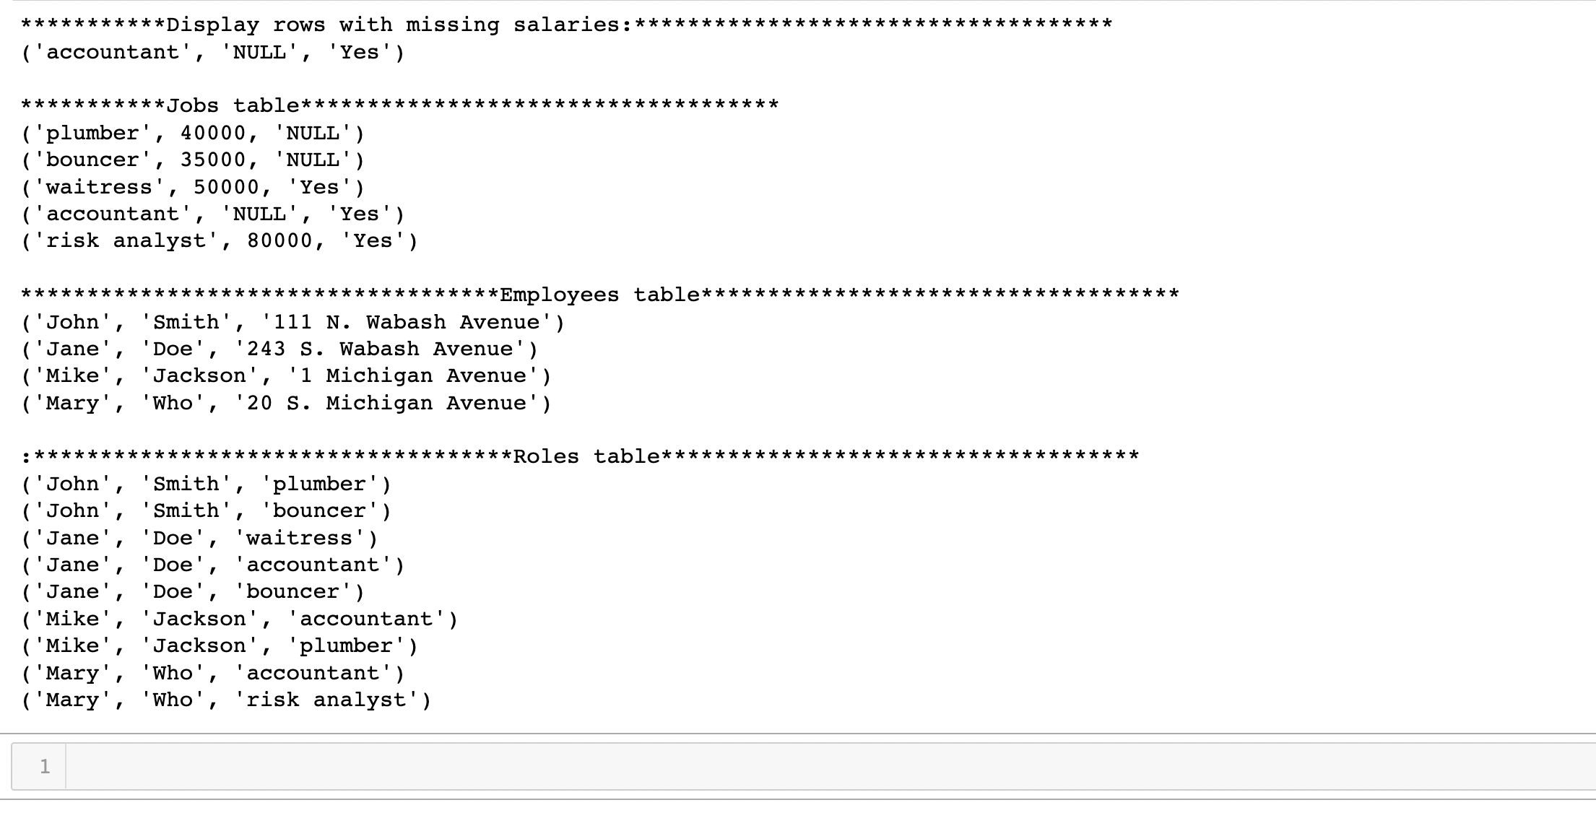

2-D

